
YEAR 11 MOTION TEST 1 November 2012

Total Marks = [50] Time: 50 mins

NAME:

Question 1 (4 marks)
Complete the following table by labeling each quantity as a scalar or a vector and giving the SI unit for that quantity.
Quantity Scalar or Vector SI Unit
Mass
Force
Speed
Acceleration
Question 2 (4 marks)
Liam and Charlie are on their way to school and they run out of petrol not far from a service station and decide to push their car to the service station to refill it. Liam is able to exert a force of 600 N and Charlie a force of 660 N.
The mass of the car is 1150 kg and there is a frictional force of 850 N. Both boys push from the rear of the car in the same direction.

(a) Using the picture below, show all of the forces, with their magnitudes, acting on the car under these conditions. (3 marks)
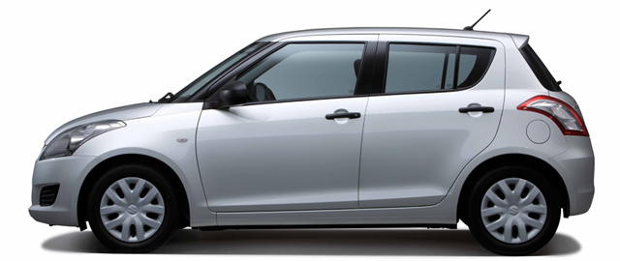

(b) What is the magnitude of the resultant force acting on the car under these conditions? (1 mark)
Question 3 (3 marks)
Sam and Tarquin are playing with their model trainset, and they decided that it would be very cool to graph the train’s velocity as it moves along a section of straight track. Their graph is shown below.
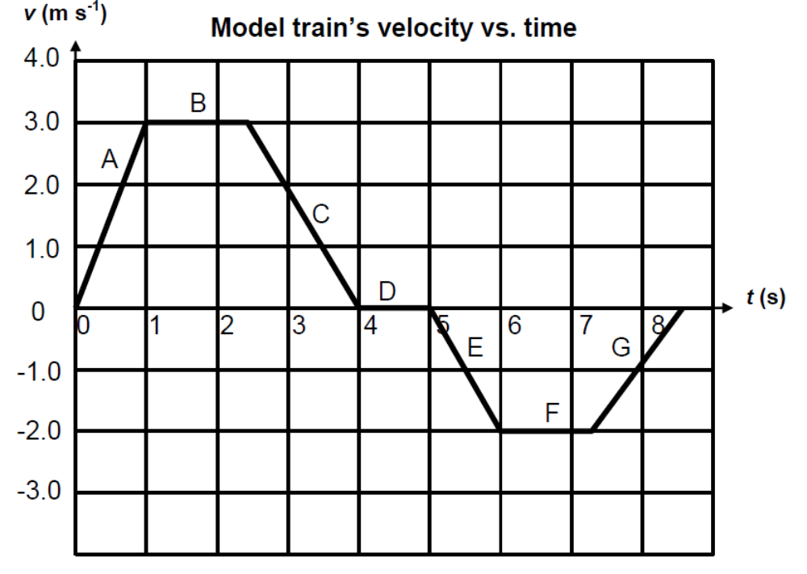
(a) During which section of the graph is the acceleration the greatest? (1 mark)

Circle the correct answer: A B C D E F G

(b) During which section is the train not moving? (1 mark)

Circle the correct answer: A B C D E F G

(c) At the end of the journey, the train’s displacement relative to its starting position will be:
(1 mark)
Circle the correct answer: Positive Zero Negative

Question 4 (3 marks)
A sudden and strong thunderstorm caused a 40.0 kg branch to break off a tree and fall from 9.00 m above the ground. The branch hit the roof of a house under the tree. Assume the branch was in free fall and the average height of the roof was 3.50 m above the ground.
Calculate the speed of the branch when it hit the roof.

Question 5 (10 marks)

A flea’s jump is one of the most impressive examples of acceleration in the animal kingdom. By pushing its legs against the ground, the flea can attain an initial upward velocity of 1.00 m s⁻¹ in 10.0 milliseconds.
Calculate:
(a) the flea’s average acceleration over this time (that is, while leaving the ground). (3 marks)

(b) the force acting on the flea during this time if it has a mass of 2.00 mg. (4 marks)

(c) the maximum height that the flea can reach if its initial velocity is vertically upward. (Hint: once the flea leaves the ground, it is affected only by gravity.) (3 marks)

Question 6 (10 marks)
An experiment is conducted in which an object with a mass of 10 kg is placed on a scale sitting
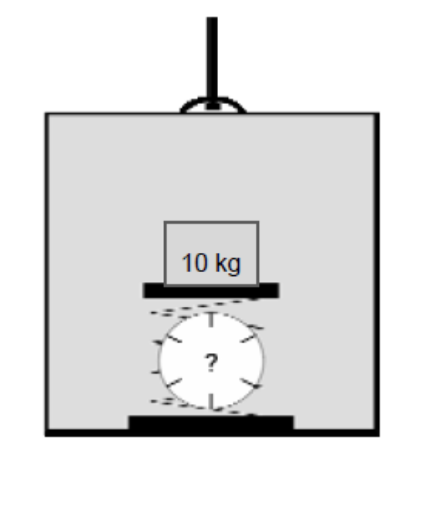
on the floor of an elevator, as shown in the diagrams below. Assuming the local gravity is
9.8 m s⁻², estimate the reading of the scale in newtons when:

(a) (i) the elevator is stationary; (1 mark)

Answer:

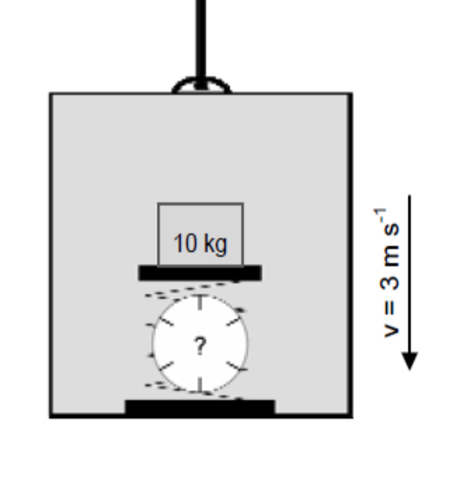

(ii) the elevator moves down at a constant velocity of 3 ms⁻¹.
(2 marks)

Answer:

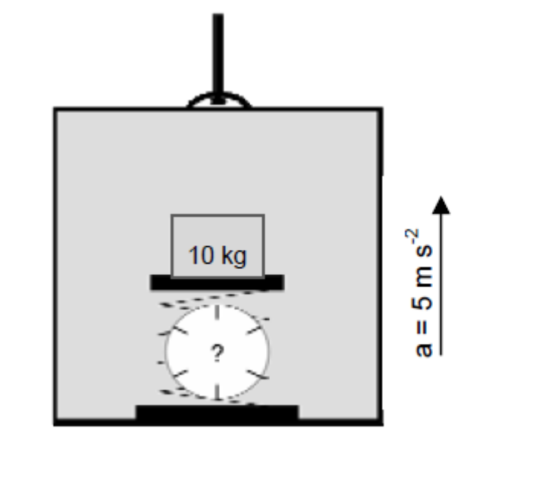

(iii) the elevator accelerates up at a constant acceleration of 5 ms⁻² (2 marks)

During the experiment, while the elevator was accelerating up at a constant acceleration, the cable suddenly broke and the elevator began to fall freely.
- (i) Determine the new scale reading. (2 marks)
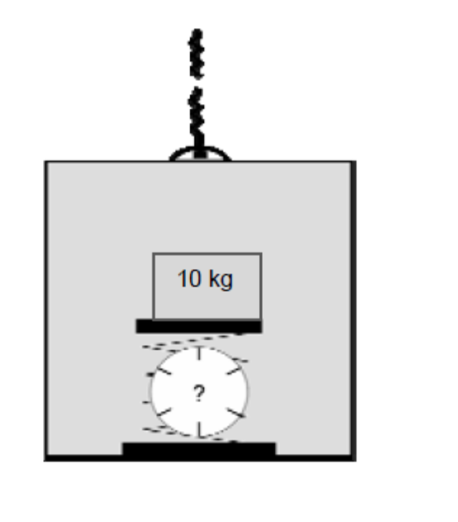

(ii) The elevator was moving upward at 5.30 m s-1 when the cable broke. It took 1.50 s to reach the ground. How high above the ground was the elevator when the cable broke? (2 marks)

Modern elevators are equipped with speed governors that apply a braking friction when a maximum speed is exceeded. These brakes bring the elevator slowly to a stop.
Explain why it is desirable for the elevator to be brought to a stop slowly rather than quickly. (1 mark)

Question 7 [10 marks]
A girl on a sledge slides down a slope at the snowfields. The total mass of the girl and the sled is 105 kg. The record of her journey from A to D is recorded on a combined stopwatch-speedometer attached to the sledge. The readings of this instrument at positions A , B , C and D are shown in the table below.

A
B
D
C
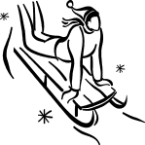

Position | A | B | C | D
Time (s) | 0 | 6.0 | 10.0 | 15.0
Speed (m/s) | 0 | 8.0 | 8.0 | 0

(a) Sketch a speed versus time graph for the sleds journey from A to D on the axes provided below. (2 marks)

speed
(m/s)

time (s)

(b) Calculate the average deceleration and hence retarding force acting on the sledge during stage CD. (2 marks)

(c) Use the graph to calculate the distance travelled from A to D. (2 marks)

(d) If stage BC is at an angle of 12° to the horizontal, calculate the frictional force acting on the sledge during that stage. (2 marks)

(e) If the frictional force acting on the sledge during stage AB is the same as that during stage BC, calculate the angle to the horizontal of the slope in stage AB (use a value of 200 N for the frictional force if you have no answer from above). (2 marks)

Question 8 (6 marks)
Max and Dylan are out shopping and decide to do a Physics experiment at Woolworths. They tie two shopping trolleys together with a light rope and pull them along with a force of 250 N.



250 N

The first trolley has a mass of 10.0 kg and the second a mass of 40.0 kg. Frictional forces for each trolley are estimated to be about 10% of their weight.
- What frictional forces are acting on each trolley? (1 mark)
- With what acceleration will the two trolleys move? (2 marks)
- What will be the tension in the rope that is pulling the empty trolley? (3 marks)

